**Procedures Mid-America AACA**

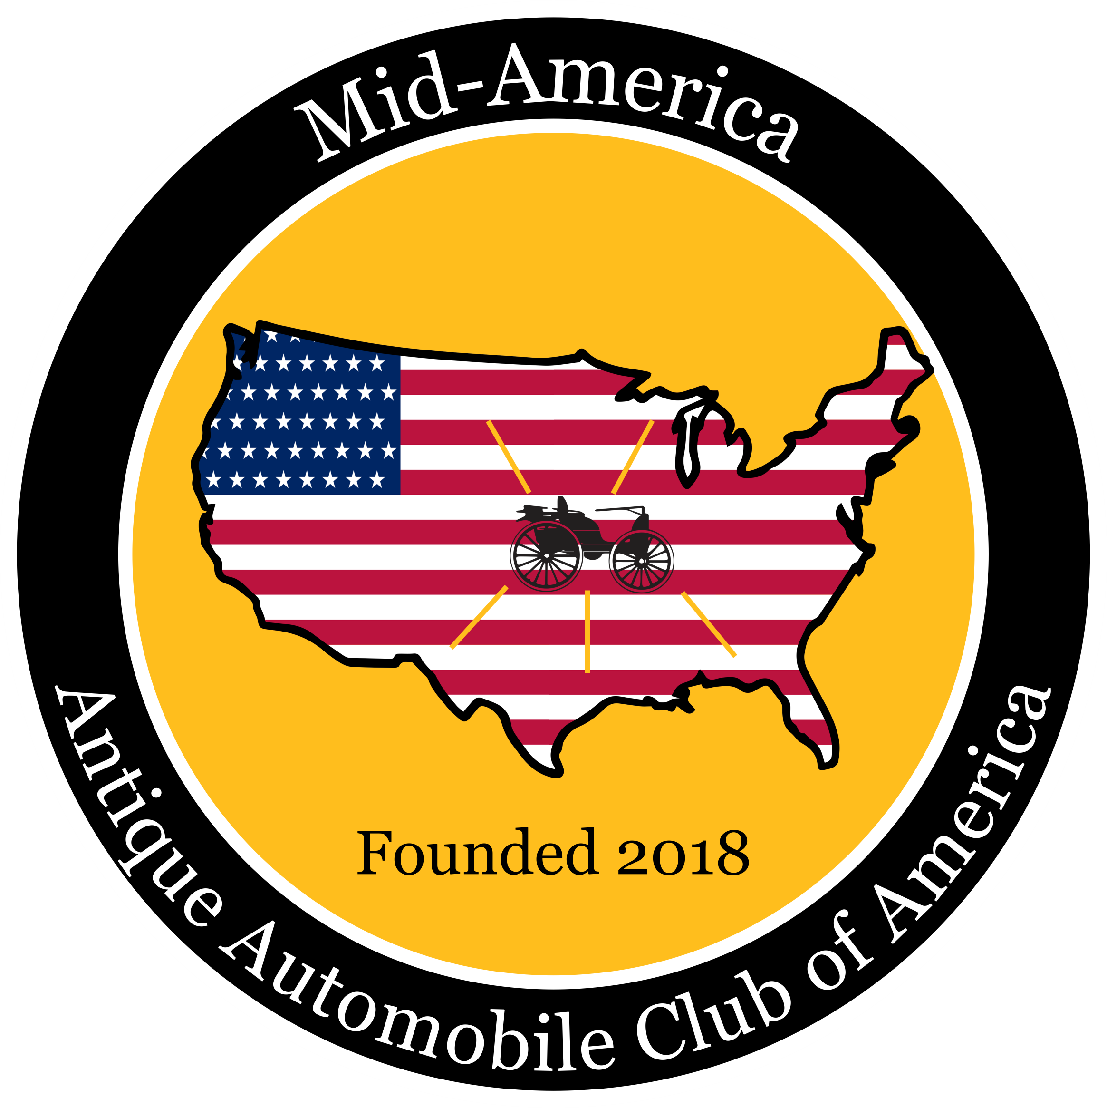

**for *“The Generator”* Newsletter**

The full Generator Newsletter is published monthly (12 times a year). All stories and

photographs are due by the 25th and if received after the 25th will be included n the next

published newsletter.

**Mid-America *Member Selected* Car Shows**

When your show has been chosen by members as a Monthly Mid-America sponsored event or a story about a car show you attended, please do the following:

• Take photos of your event. Please be sure to include names left to right of people

who are in a photo. If unknown, state that.

• Please limit your photos to 5 for submission to the Newsletter Editor, Martie

Kernodle email: [editormidamerica@gmail.com](mailto:editormidamerica@gmail.com)

• Please submit a short story about your event. Don’t worry about the article being

perfect,our editing team will look it over. (Call Martie Kernodle, 816-686-6700 if

questions)

Other Events Attended (not selected as an official Mid-America AACA event)

When you attend an event that you really enjoyed, please send a short article and

photos, if available. Again label the photos.

***“Member and Their Cars”*** stories will be published from articles you send about your vehicle of choice.

Here is what members say they like to know:

Why that car? (always wanted one, love at first sight, etc.)

Where did you find it?

What are features and facts about your ride?

And anything else that you want to share.

Pictures please – at least 2 - 4 and would like to have the owner(s) in a photo

**For Sale:** Advertising a vehicle or parts for sale is free to all Mid-America AACA Members. Please submit one photo, vehicle information, the price and contact information.

**New Member(s) You Sponsor**

If you sponsor a new Member, please send the Newsletter Editor a photo and brief

information about your member so we can introduce them to all members in our

newsletter.

***Please send articles and photos to: editormidamerica@gmail.com***